**Formulas and Derivation for coaxial camera**

From My Papers\Figures\Figure2.png

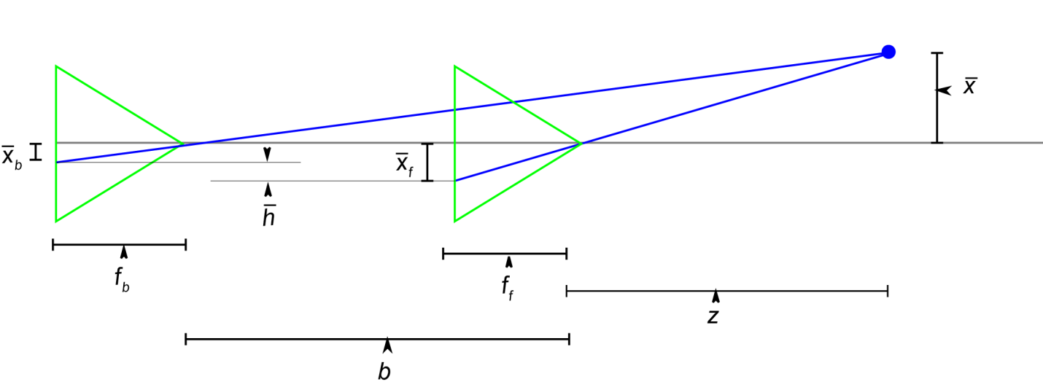

Projection Equations

(1)

(2)

where X, Y, and Z are coordinates in the scene and x and y are image coordinates.

Differentiate to get optical flow (also can be done geometrically page 110):

(3)

(4)

(4)

(5)

(6)

(7)

(8)

(9)

(10)

(11)

(12)

(13)

(14)

(15)

For y to end an the axis, rotate through the angle:

(16)

(17)

(18)

substitute:

(19)

(20)

For the coaxial camera this becomes:

(21)

(22)

solve for and set equal:

(23)

where

(24)

We still have two unknowns, h and Z, however, for the coaxial camera, and are related by:

(25)

(26)

(27)

(28)

(29)

(30)

(31)

We find or using the following energy equation along a radial line:  
 (32)

(33)  
 (34)

Once we have the estimate for h and Z we can compute W from equation (9) or (10) as follows:

(35)

(36)

QED